Nội dung cần TH:

B1/ Code: Chuong trinh nhap vao 1 so nhi phan xuat ra decimal, va cho biet so thap phan do co doi xung khong (isSymmetric)?

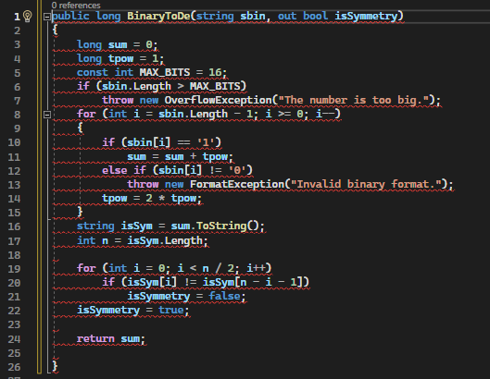

public long BinaryToDe(string sbin, out bool isSymmetry)

{

long sum = 0;

long tpow = 1;

const int MAX_BITS = 16;

if (sbin.Length > MAX_BITS)

throw new OverflowException("The number is too big.");

for (int i = sbin.Length - 1; i >= 0; i--)

{

if (sbin[i] == '1')

sum = sum + tpow;

else if (sbin[i] != '0')

throw new FormatException("Invalid binary format.");

tpow = 2 * tpow;

}

string isSym = sum.ToString();

int n = isSym.Length;

for (int i = 0; i < n / 2; i++)

if (isSym[i] != isSym[n - i - 1])

isSymmetry = false;

isSymmetry = true;

return sum;

}

B2/ ve bieu do node, thiet ke test case

B3/ Tao project va class test cho tung test case (co bat ngoai le) va Data_Driven voi file csv tam (chua bat ngoai le)

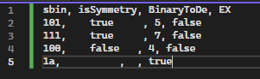

B4/ Them class Data_Driven (bat ngoai le)